This camera would travel over the tops of the plants and snap pictures at different locations to monitor their growth. Once the camera is finished capturing images of the plants, it would travel back to a wireless charging station to fill its battery as well as upload all the images and locations of the plants. One of the engineers explained that this technology would make it cheaper to implement fewer cameras for a larger farming facility.

Each farming shelf could use just one camera that would travel the shelf in an oval pattern. Canon has been developing high quality imaging equipment for over 80 years and could bring a disruptive technology for farms in the near future. This new system combined with artificial intelligence and machine learning could allow indoor farmers to receive quicker growing insights for making operational decisions.

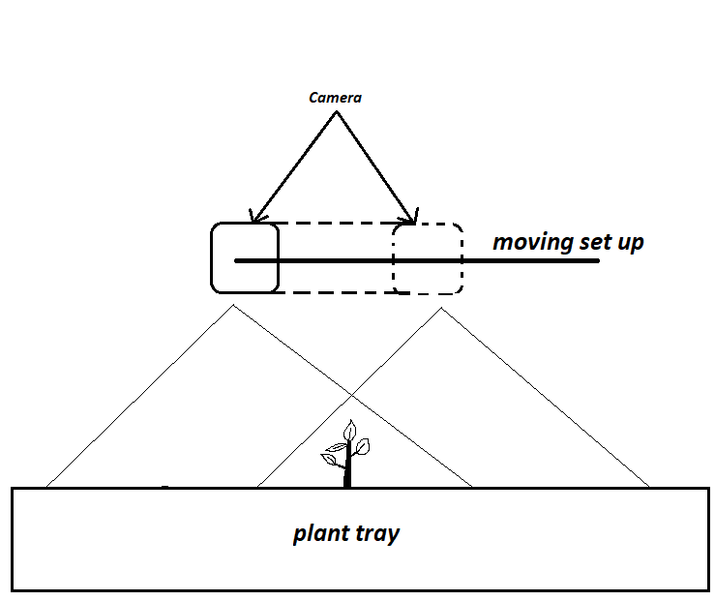

Suggested type of camera: wide angle and high definition.

The mobile structure could be made using servos and controlled using a central computer. The software would have to be made from scratch.